|  |  |  |  |
| --- | --- | --- | --- |
| C:\Users\Student\Desktop\21_1_19\ISO\ABMS Logo (1).jpg | **Akhil Bharatiya Maratha Shikshan Parishad's Anantrao Pawar College of Engineering & Research** | |  |
| **Record No.:** ACA/D/003B  **Revision: 00** | **DoI:** |
| **Internship Diary** | | | |

# Department of Information Technology Engineering

**TE (IT) INTERNSHIP DIARY**

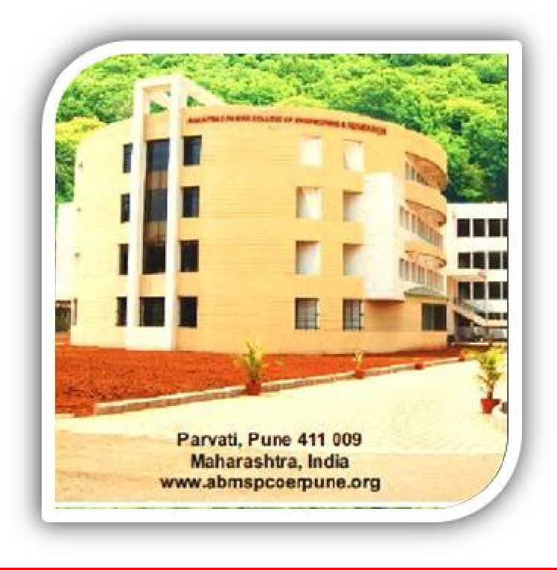

**Name of the Student: Dishank A Shekokare**

**Roll No.: 5316**

**PRN: 72220090M**

**Class: T.E. (IT) Sem-VI**

**Department: Information Technology**

**Name of Industry: Sharadchandra Techventures**

**INDEX**

|  |  |  |
| --- | --- | --- |
| **Sr. No.** | **CONTENT** | **PAGE NUMBER** |
| 1 | Instructions to students |  |
| 2 | Acknowledgment |  |
| 3 | Discussions with HR Manager |  |
| 4 | Company Profile |  |
| 5 | Daily Report |  |
| 5 | Internship Acceptance Letter |  |
| 6 | Undertaking |  |
| 7 | Certificate of Internship Given by Company |  |
| 8 | Industry Feedback |  |
| 9 | Internal Faculty Feedback |  |

|  |  |  |  |
| --- | --- | --- | --- |
| C:\Users\Student\Desktop\21_1_19\ISO\ABMS Logo (1).jpg | **Akhil Bharatiya Maratha Shikshan Parishad's Anantrao Pawar College of Engineering & Research** | |  |
| **Record No.:** ACA/D/003B  **Revision: 00** | **DoI:** |
| **Internship Diary** | | | |

**INSTRUCTIONS TO STUDENTS**

1. Students must observe carefully and understand the activities/processes in the industry every day during the internship.
2. Record the processes observed, in the Internship Record Book. Neat sketches to be drawn to explain the observations in the space provided the record book.
3. Everyday work, as recorded in the Record Book, should get verified and endorsed with signature by the Engineer/Supervisor/Manager responsible for his/her training. Student should request the authorized signatory for the record book, to write his name and designation, at least at one place in the record book.
4. On every working day, the student must strive to learn new knowledge. He/she must be inquisitive and make best use of the opportunity given for learning. Student must enter all the key learnings in the record book.
5. Student must write the company profile, Company's organization chart, Products, market share etc. All this information can be downloaded from their official website in addition to the interactions with the company employees.
6. Student must ensure that he/she follows all the rules including the safety norms of the company and maintain to the timings allotted to them.
7. Must attend the industry every day except for the declared industry holidays and the weekly off.
8. Must observe the working of the plant and carry out the tasks given by the plant supervisor allotted to them.
9. Ensure that they do not do any unsafe act and do not go to any other workplace other than the one allotted to them without permission.
10. For granting the term it is mandatory to attend every day except for industry declared holidays.
11. Due weightage of marks will be allotted for a good presentation in the Record book.
12. Names and telephone numbers, of the expert personnel with whom the student is coming in to contact during the training, to be mentioned for future Industry- Institution Interaction. Students must ensure that they behave well during the training period and be a good ambassador of our Institution.
13. Students should request and obtain permission, to have one session of discussions with HR Manager of the respective Industry. Points of discussions to be recorded in the Internship Record Book.

|  |  |  |  |
| --- | --- | --- | --- |
| C:\Users\Student\Desktop\21_1_19\ISO\ABMS Logo (1).jpg | **Akhil Bharatiya Maratha Shikshan Parishad's Anantrao Pawar College of Engineering & Research** | |  |
| **Record No.:** ACA/D/003B  **Revision: 00** | **DoI:** |
| **Internship Diary** | | | |

**ACKNOWLEDGEMENT**

I have taken efforts in this Internship. However, it would not have been possible without the kind support and help of many individuals and organizations. I would like to extend my sincere thanks to all of them.

I am highly indebted to Principal **Dr. S. B. Thakare**, for the facilities provided to accomplish this Internship.

I would like to express my special thanks of gratitude to my Head of the Department, **Prof. Devika Rankhambe** For their guidance in my internship**.**

I would like to thank **Prof. A. N. Kalal** Department Internship coordinator for their support and advice to get a complete internship in the above-said organization.

I am extremely grateful to my department staff members and friends who helped me in the successful completion of this Internship.

Any endeavor cannot lead to results unless and until a proper platform is provided for the same. I express our thanks to Company For allowing me to undertake this

Internship program.

I sincerely thank Management for their constant guidance, valuable suggestions, and encouragement throughout the progress of the Internship program.

I would also like to take this opportunity to thank all Internship Guides for their precious guidance and administration staff for their help.

And last but not least I would like to thank our parents and colleagues for their motivational support.

**Name of Student: Dishank A Shekokare**

|  |  |  |  |
| --- | --- | --- | --- |
| C:\Users\Student\Desktop\21_1_19\ISO\ABMS Logo (1).jpg | **Akhil Bharatiya Maratha Shikshan Parishad's Anantrao Pawar College of Engineering & Research** | |  |
| **Record No.:** ACA/D/003B  **Revision: 00** | **DoI: 21/01/2019** |
| **Internship Diary** | | | |

**Discussions with HR Manager**

We discussed about how to analysis the project and how to work on it as per the requirement of the client. The projects done during the internship are based on the tags of programming language HTML & CSS.

### About Roles and Responsibility -

As an intern my responsibilities at Sharadchandra Techventures was to cover all aspects of creating web. application to become a web developer. For this required core knowledge about designing tools like HTML, CSS, Bootstrap, JavaScript, etc.

### About Work environment –

Web Developer generally works at client side dealing with the web page design, graphics that is accessible to the user.

|  |  |  |  |
| --- | --- | --- | --- |
| C:\Users\Student\Desktop\21_1_19\ISO\ABMS Logo (1).jpg | **Akhil Bharatiya Maratha Shikshan Parishad's Anantrao Pawar College of Engineering & Research** | |  |
| **Record No.:** ACA/D/003B  **Revision: 00** | **DoI: 21/01/2019** |
| **Internship Diary** | | | |

# Company Profile

### Name of the Company: Sinrem Tech Address: Pune

### Phone: +91 95031 19046

**Email: sinremtech@gmail.com**

**About us:**

### Sharadchandra Techventues, where quality and creativity collide. We are a top IT business that specializes in offering state-of-the-art software solutions that are customized to satisfy your various needs. With expertise in desktop, Android, and web application development, our committed team of talented specialists delivers a full range of solutions for your digital needs.

### Our Mission:

Our mission at Sharadchandra Techventures. is to provide excellent services that seamlessly blend innovation, usability, and scalability. We work to comprehend your distinct idea and bring it to life using a client-centric methodology. Our solid and smooth software solutions demonstrate our ongoing dedication to quality. With our experience, discover the possibilities of a changing digital landscape. We have the technological know-how to realize your ideas for an engaging website, an intuitive Android app, or a potent desktop program. At Sharadchandra Techventures, come along on an innovative, dependable, and successful adventure with us.

|  |
| --- |
| **Daily Report of activities done in Internship** |
| **Day: 1 Date:-** |

**Signature of the Student Signature of Competent Authority**

|  |
| --- |
| **Daily Report of activities done in Internship** |
| **Day: 2 Date:-** |

**Signature of the Student Signature of Competent Authority**

|  |
| --- |
| **Daily Report of activities done in Internship** |
| **Day: 3 Date:-** |

**Signature of the Student Signature of Competent Authority**

|  |
| --- |
| **Daily Report of activities done in Internship** |
| **Day: 4 Date:-** |

**Signature of the Student Signature of Competent Authority**

|  |
| --- |
| **Daily Report of activities done in Internship** |
| **Day: 5 Date:-** |

**Signature of the Student Signature of Competent Authority**

|  |
| --- |
| **Daily Report of activities done in Internship** |
| **Day: 6 Date:-** |

**Signature of the Student Signature of Competent Authority**

|  |
| --- |
| **Daily Report of activities done in Internship** |
| **Day: 7 Date:-** |

**Signature of the Student Signature of Competent Authority**

|  |
| --- |
| **Daily Report of activities done in Internship** |
| **Day: 8 Date:-** |

**Signature of the Student Signature of Competent Authority**

|  |
| --- |
| **Daily Report of activities done in Internship** |
| **Day: 9 Date:-** |

**Signature of the Student Signature of Competent Authority**

|  |
| --- |
| **Daily Report of activities done in Internship** |
| **Day: 10 Date:-** |

**Signature of the Student Signature of Competent Authority**

|  |
| --- |
| **Daily Report of activities done in Internship** |
| **Day: 11 Date:-** |

**Signature of the Student Signature of Competent Authority**

|  |
| --- |
| **Daily Report of activities done in Internship** |
| **Day: 12 Date:-** |

**Signature of the Student Signature of Competent Authority**

|  |
| --- |
| **Daily Report of activities done in Internship** |
| **Day: 13 Date:-** |

**Signature of the Student Signature of Competent Authority**

|  |
| --- |
| **Daily Report of activities done in Internship** |
| **Day: 14 Date:-** |

**Signature of the Student Signature of Competent Authority**

|  |
| --- |
| **Daily Report of activities done in Internship** |
| **Day: 15 Date:-** |

**Signature of the Student Signature of Competent Authority**

|  |
| --- |
| **Daily Report of activities done in Internship** |
| **Day: 16 Date:-** |

**Signature of the Student Signature of Competent Authority**

|  |
| --- |
| **Daily Report of activities done in Internship** |
| **Day: 17 Date:-** |

**Signature of the Student Signature of Competent Authority**

|  |
| --- |
| **Daily Report of activities done in Internship** |
| **Day: 18 Date:-** |

**Signature of the Student Signature of Competent Authority**

|  |
| --- |
| **Daily Report of activities done in Internship** |
| **Day: 19 Date:-** |

**Signature of the Student Signature of Competent Authority**

|  |
| --- |
| **Daily Report of activities done in Internship** |
| **Day: 20 Date:-** |

**Signature of the Student Signature of Competent Authority**

|  |
| --- |
| **Daily Report of activities done in Internship** |
| **Day: 21 Date:-** |

**Signature of the Student Signature of Competent Authority**

|  |
| --- |
| **Daily Report of activities done in Internship** |
| **Day: 22 Date:-** |

**Signature of the Student Signature of Competent Authority**

|  |
| --- |
| **Daily Report of activities done in Internship** |
| **Day: 23 Date:-** |

**Signature of the Student Signature of Competent Authority**

|  |
| --- |
| **Daily Report of activities done in Internship** |
| **Day: 24 Date:-** |

**Signature of the Student Signature of Competent Authority**

|  |
| --- |
| **Daily Report of activities done in Internship** |
| **Day: 25 Date:-** |

**Signature of the Student Signature of Competent Authority**

|  |
| --- |
| **Daily Report of activities done in Internship** |
| **Day: 26 Date:-** |

**Signature of the Student Signature of Competent Authority**

|  |
| --- |
| **Daily Report of activities done in Internship** |
| **Day: 27 Date:-** |

**Signature of the Student Signature of Competent Authority**

|  |
| --- |
| **Daily Report of activities done in Internship** |
| **Day: 28 Date:-** |

**Signature of the Student Signature of Competent Authority**

|  |
| --- |
| **Daily Report of activities done in Internship** |
| **Day: 29 Date:-** |

**Signature of the Student Signature of Competent Authority**

|  |
| --- |
| **Daily Report of activities done in Internship** |
| **Day: 30 Date:-** |

**Signature of the Student Signature of Competent Authority**

**Internship Acceptance Letter**

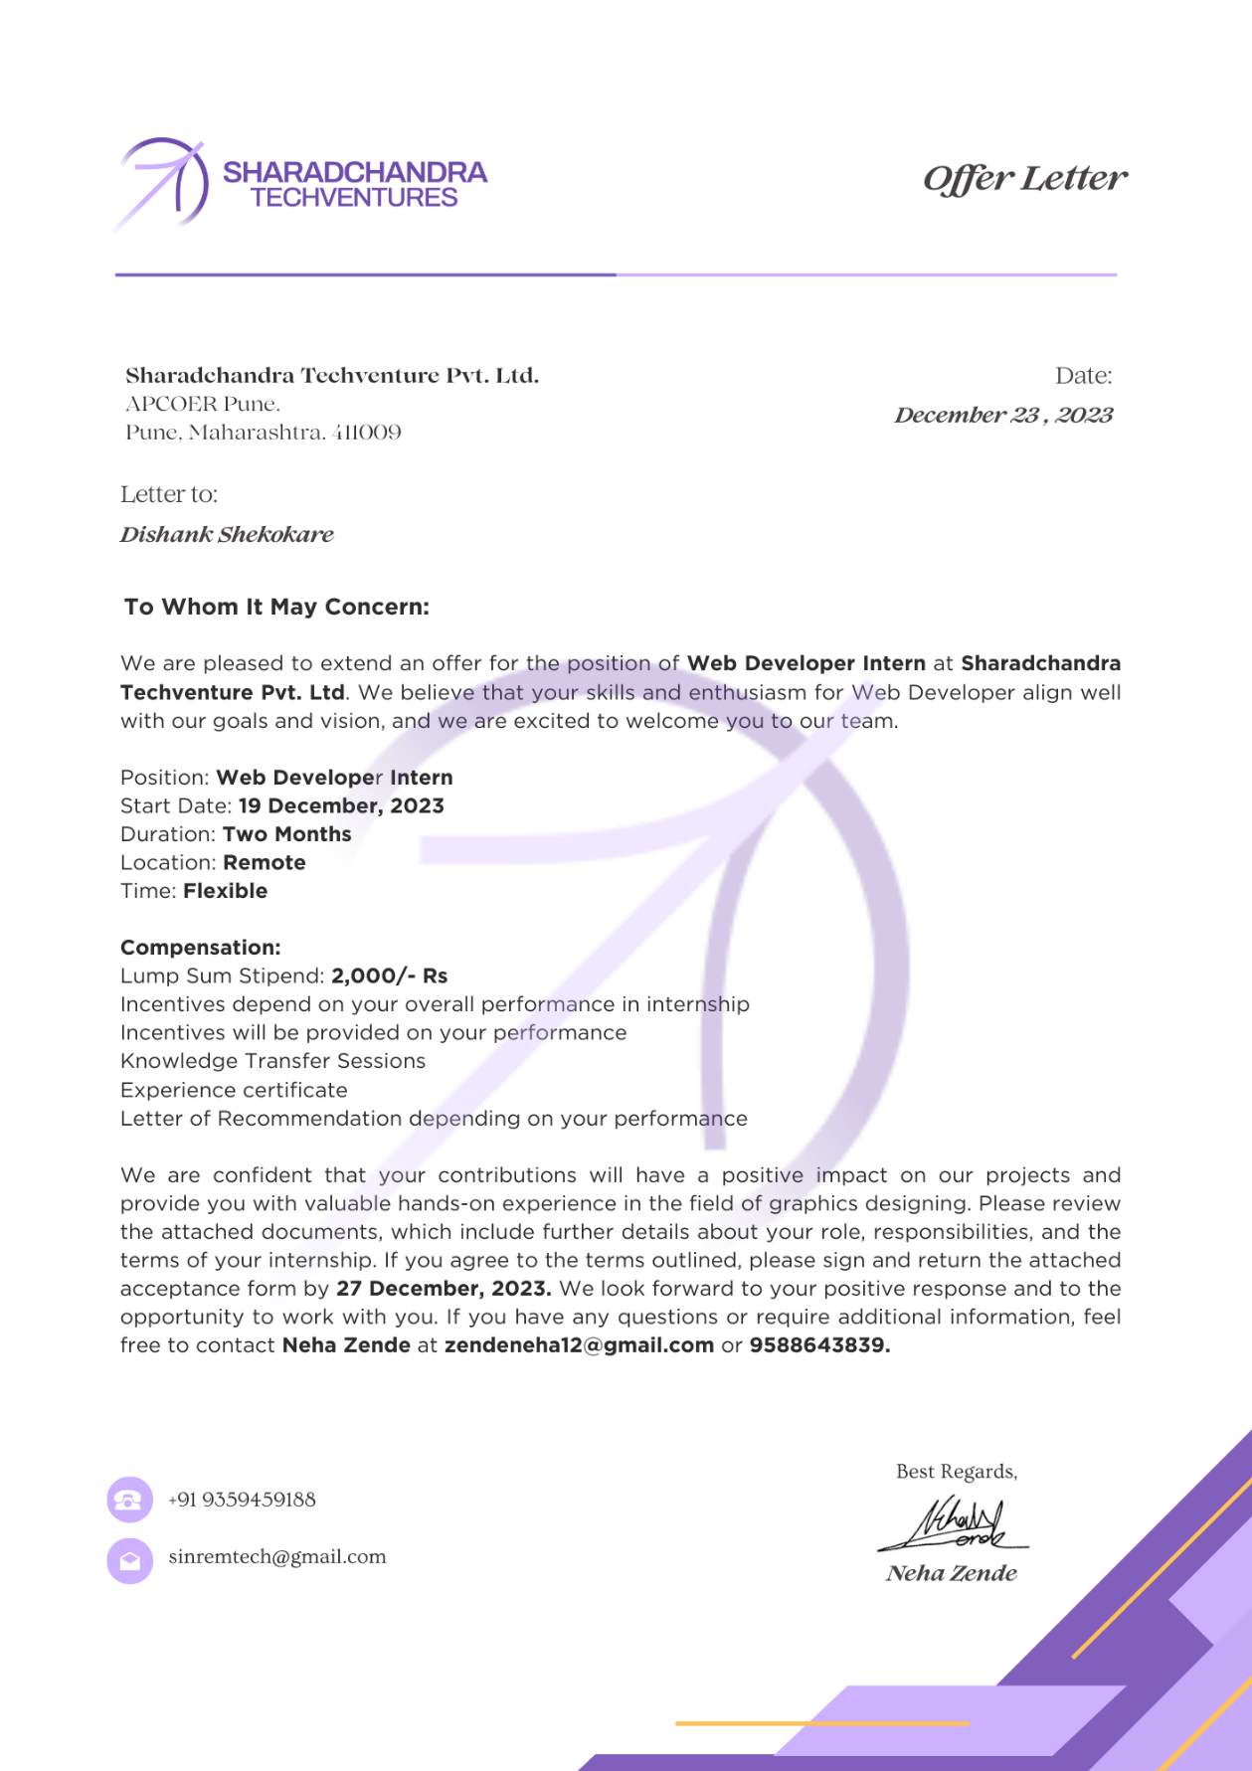

**Undertaking**

**I hereby declare that the Internship month entitled “INTERNSHIP DIARY” submitted to the Anantrao Pawar College of Engineering & Research, Pune, is a record of an original work done by me under the guidance of Prof. A. N. Kalal , Faculty of Information Technology.**

**This work is submitted in the partial fulfillment of the requirements for the completion of the work of Degree in Information Technology Engineering.**

**Name of Student**

**Dishank A Shekokare**

**Certificate of Internship Given by Company**

**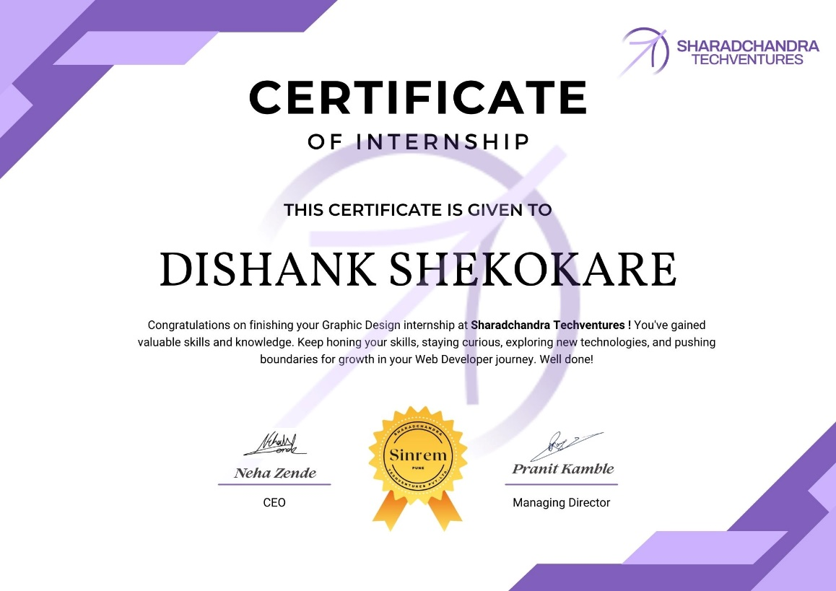**

|  |  |  |  |
| --- | --- | --- | --- |
| C:\Users\Student\Desktop\21_1_19\ISO\ABMS Logo (1).jpg | **Akhil Bharatiya Maratha Shikshan Parishad's Anantrao Pawar College of Engineering & Research** | |  |
| **Record No.:** ACA/D/003B  **Revision: 00** | **DoI: 21/01/2019** |
| **Internship Diary** | | | |

**Industry Feedback**

### Name of Organization:

**Sector:**

### Name of authorized person: Designation:

**Sign of authorized person:**

### Date:

**Please write your comments in feedback.**

|  |  |  |
| --- | --- | --- |
| **No.** | **Description** | **Feedback** |
| 1 | Which are advanced techniques/methods used in your industry? |  |
| **2** | Which software & tools are important in your industry? |  |
| **3** | What kind of technical knowledge is required for fresh Engineers in this industry? |  |
| **4** | What kind of skill is required for fresh Engineers in this industry? |  |
| **4** | What kind of responsibilities you expect from a fresh Engineer? |  |
| **6** | In your view how, much is importance of safety on site, societal issues, and environmental concern? |  |
| **7** | What are your expectations from an Engineer about organizational policies, discipline, secrecy, transparency etc.? |  |
| **8** | How you built teamwork in your organization? |  |

|  |  |  |
| --- | --- | --- |
| **9** | What kind of different modes for communication and presentation are used in your organization? |  |
| **10** | How frequently you organize training for your staff? And on which topic? |  |
| **11** | Any other Suggestions / your expectations from fresh engineers or educational institute: | |

* **Feedback From Internal Faculty:**

**Completion Mail**

**Task -1**

**Landing Page**

**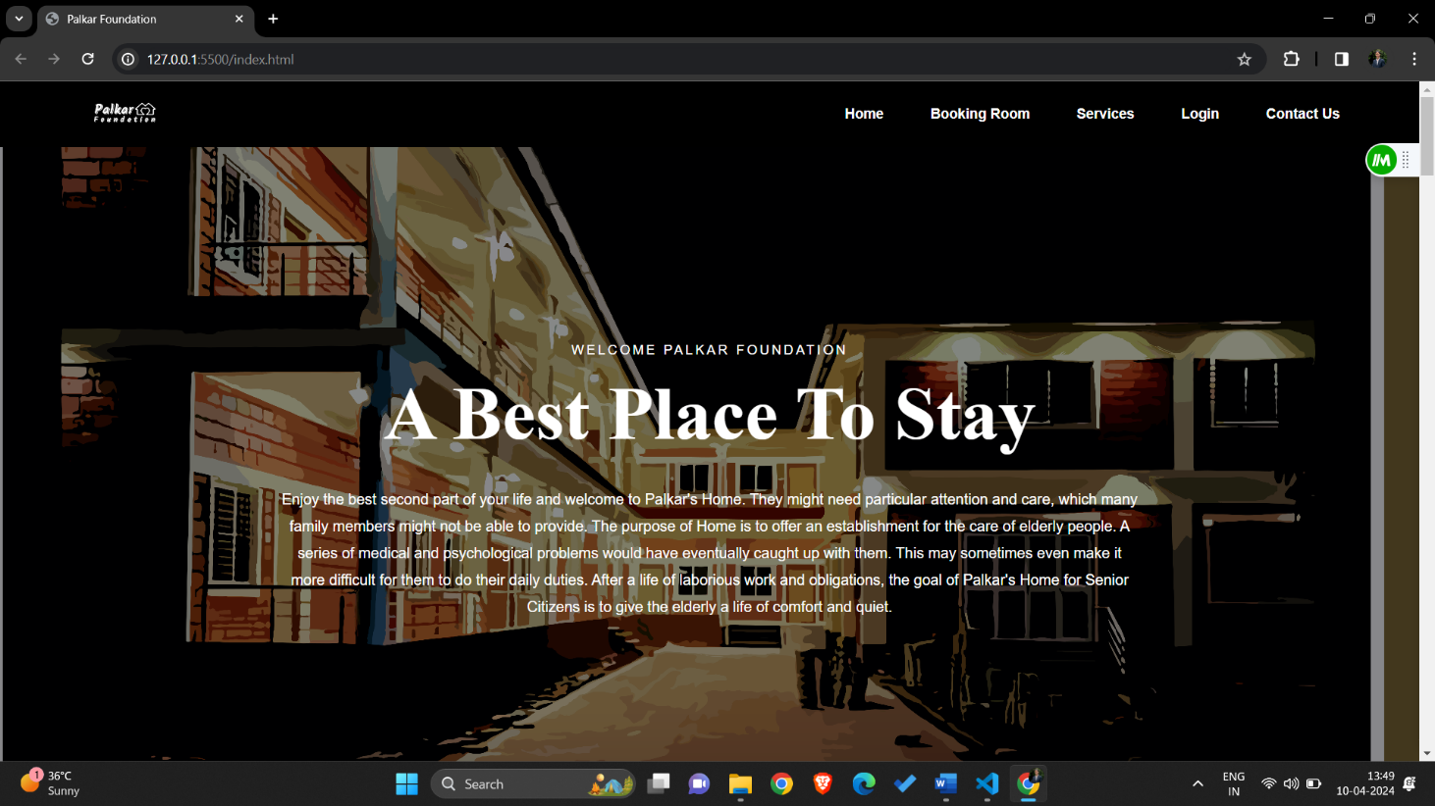**

**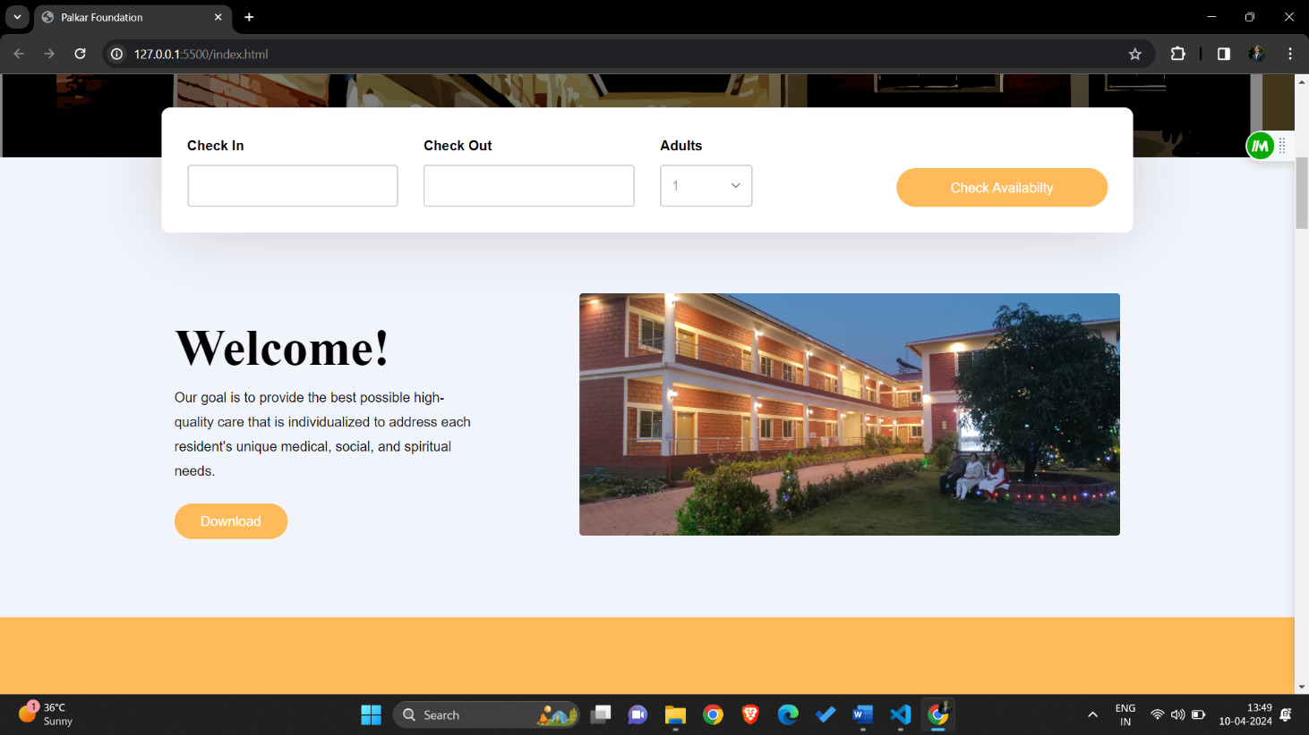**

**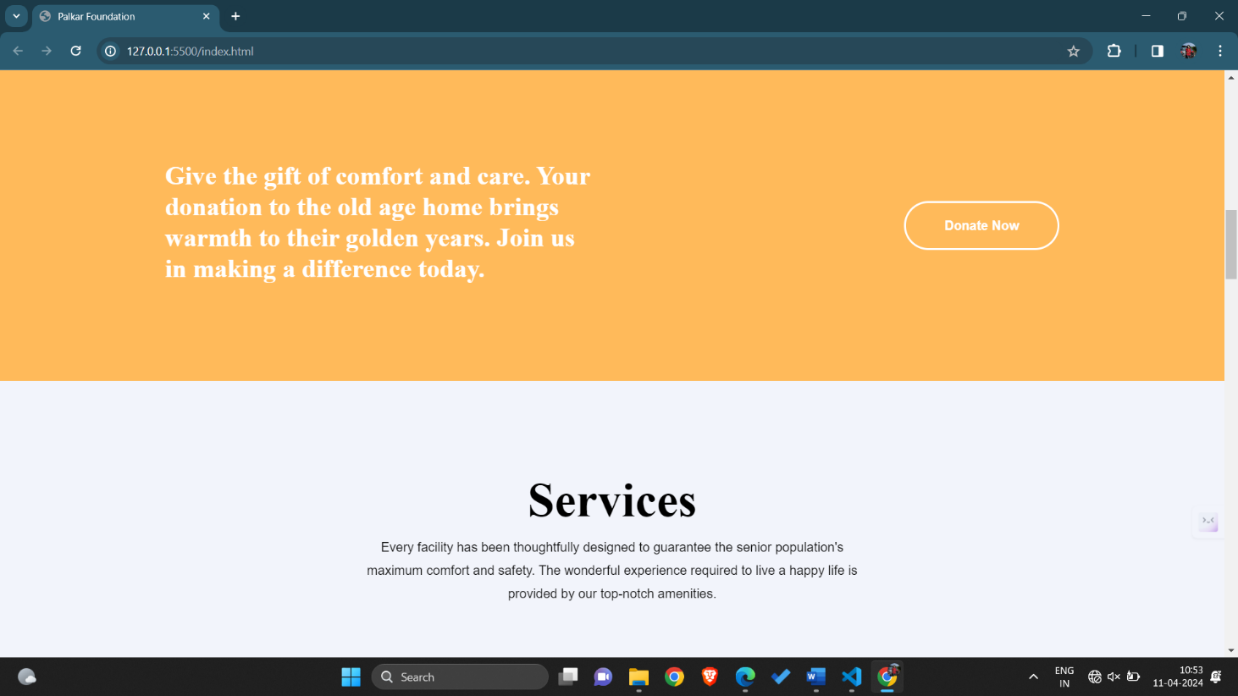**

**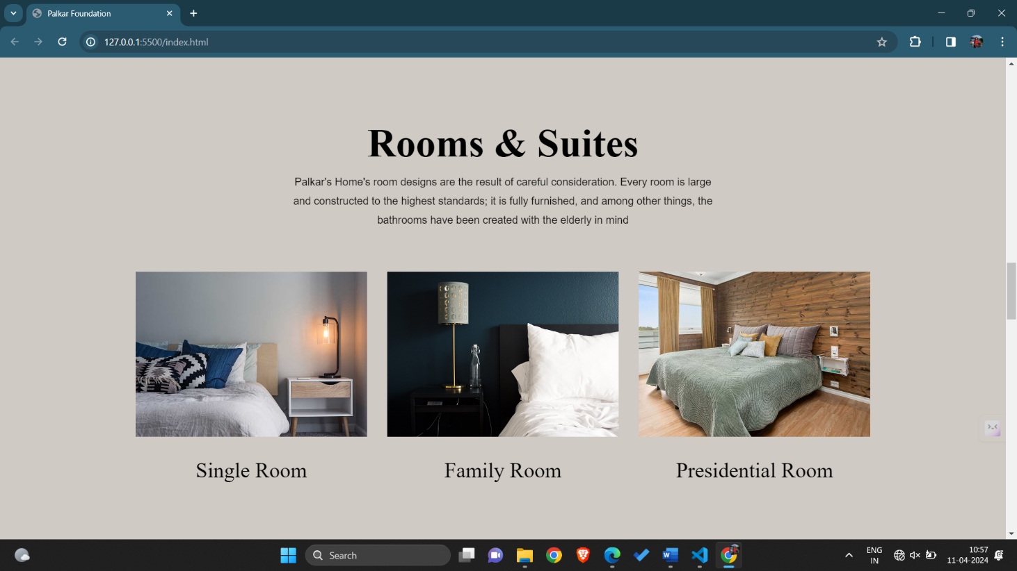**

## Task -2 Login Page

**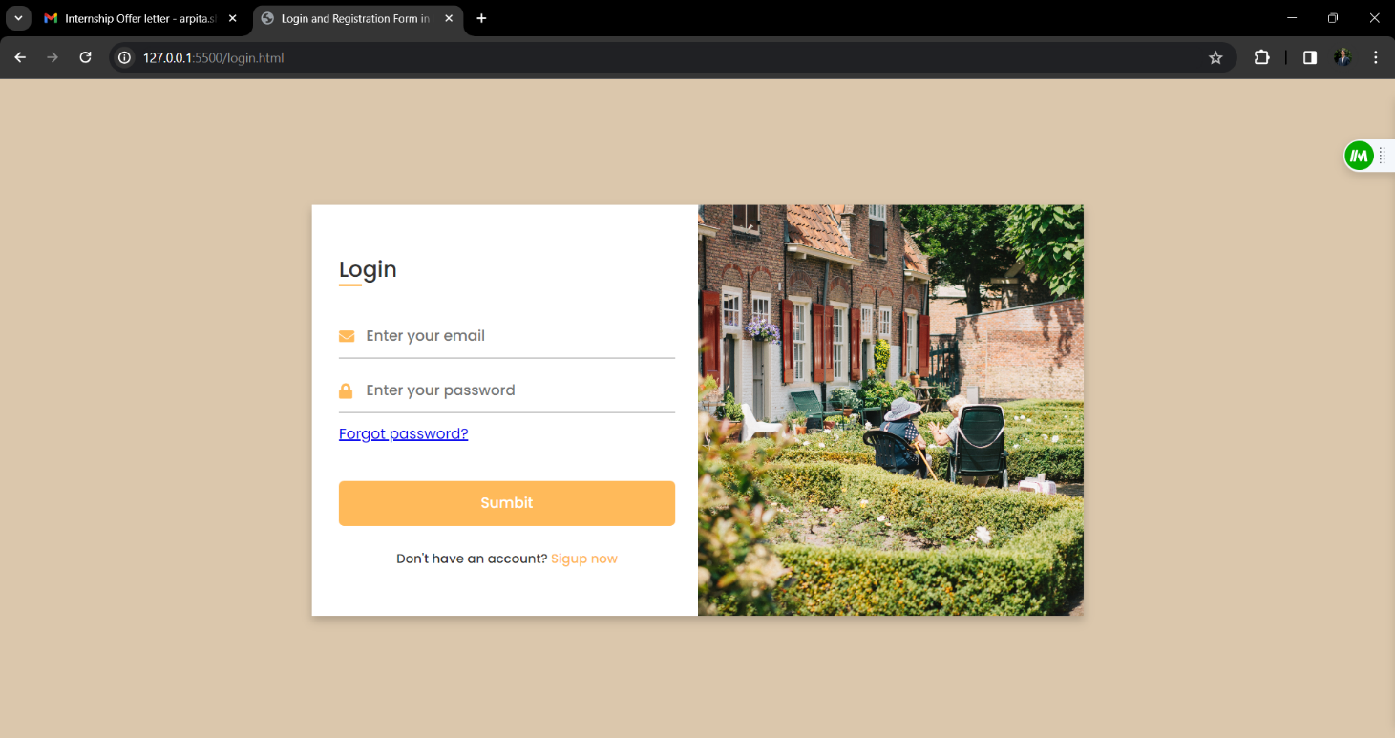**

**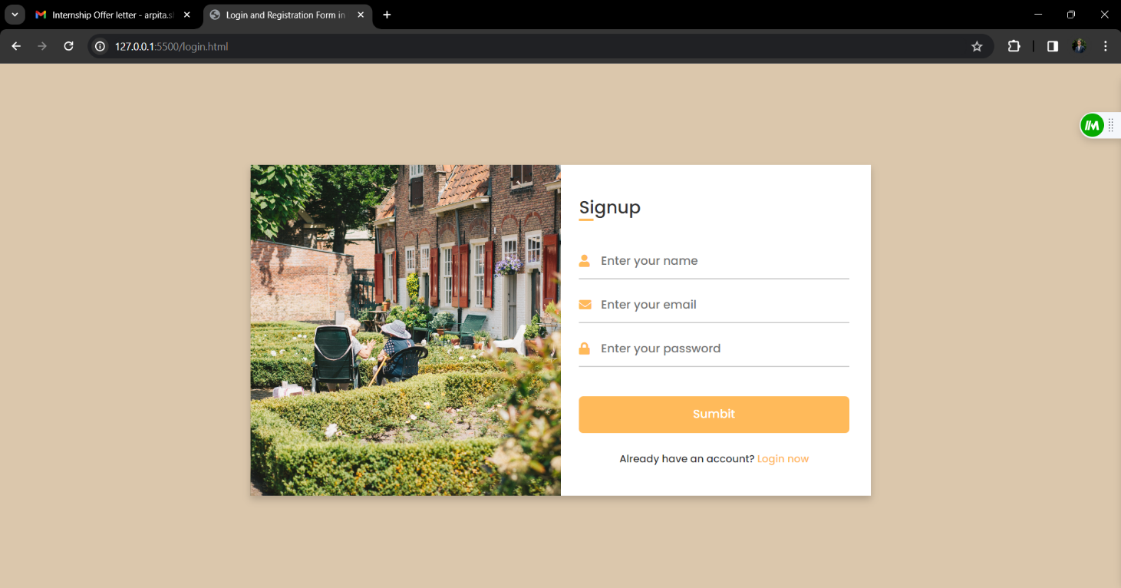**

**Task -3**

**Services Page**

**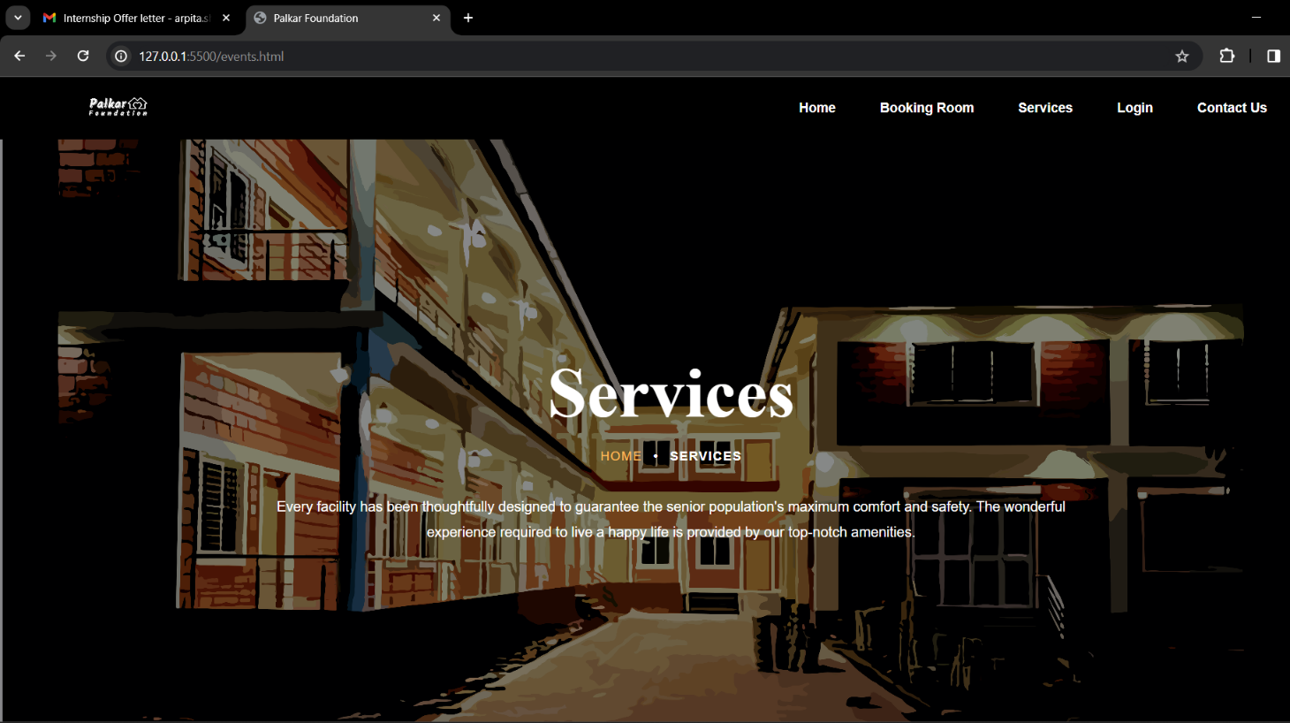**

**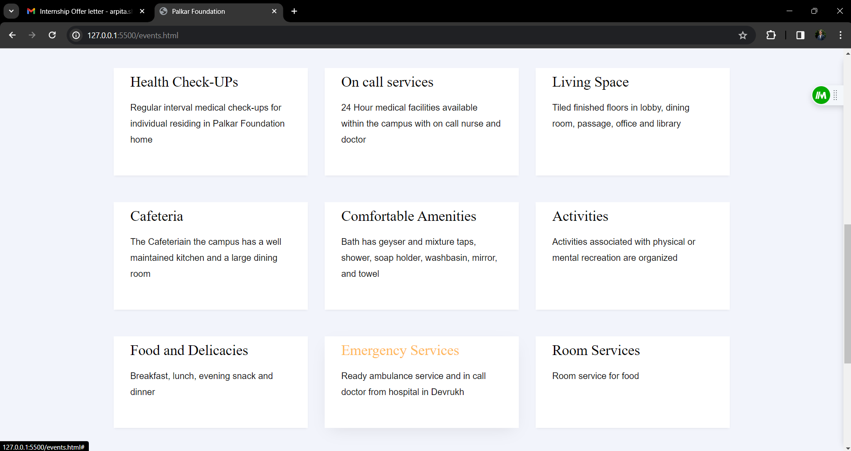**

## Task – 4 Booking Page

